## Practical 1: XML Fundamental

**Objective:**

* Understand well-formed and valid xml
* Parse XML document using Visual Studio XML editor
* Learn to validate xml document using schema

### Exercise 1 – Study RSS Feed XML

1. XML DOM is the class used to access xml document. We will practice DOM to access the Channel NewsAsia RSS feed. Really Simple Syndication(RSS) has become the standard data format for communicating news, updates or any other type of information that a company or individual wants to syndicate to a large audience. It is an XML format that consists of designated elements that are consistent for all RSS feeds and conform to the XML 1.0 specification.
2. Access CNA Website : <http://www.channelnewsasia.com/news/rss>
3. Select the content that you wanted.  
   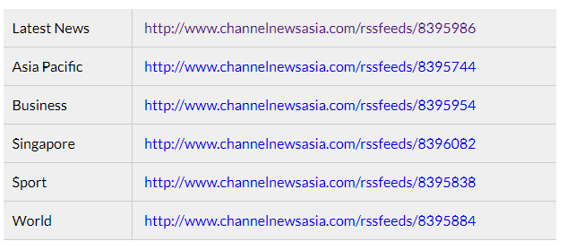

Right click one of the link, and save the xml document in your desktop. Open the xml file using Visual Studio.

1. The following is a sample of the RSS feed.

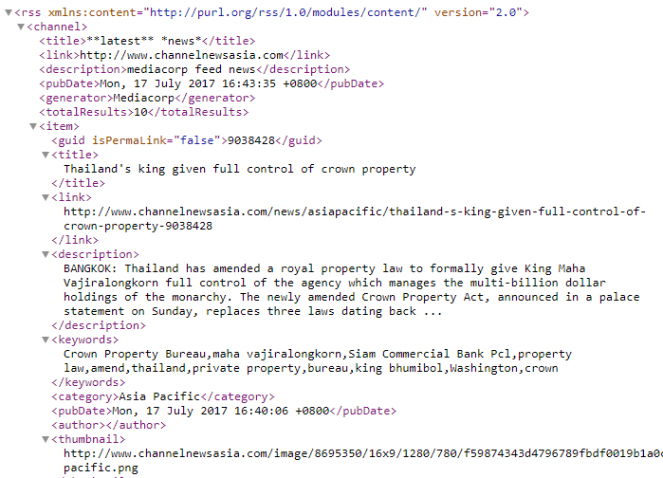

1. You can further minimize to see the list of children of <channel>.

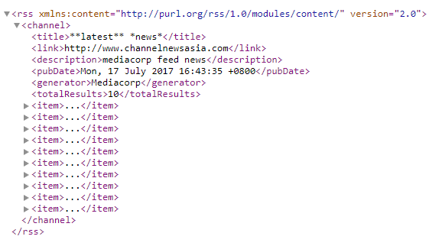

1. The RSS declaration identifies that this is an RSS document.

The <channel> element can have one or more <item> elements.

Each <item> element defines an article or "story" in the RSS feed.

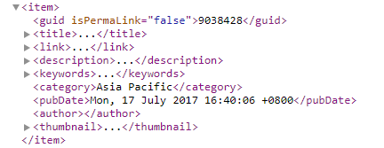

We are accessing three required child elements in the <item>

* <title> - Defines the title of the item
* <link> - Defines the hyperlink to the item
* <description> - Describes the item

### Exercise 2 - Accessing XML using DOM

1. Launch Visual Studio.
2. Create a new ASP.NET Empty Web Application project using C# template.
   * For Language, choose "Visual C#".
   * Named the project as "IT2605Prac03"
   * For the Location, specify the location of this project. Click Ok button.
3. Select an **empty** template, click OK to create project.
4. Add a new web form from solution folder and named as ***showRSS.aspx***.
5. Design the web form as below. This form allows users to select the list of articles from the title dropdown list and display the article description in description label. The articles are obtained from RSS feed.

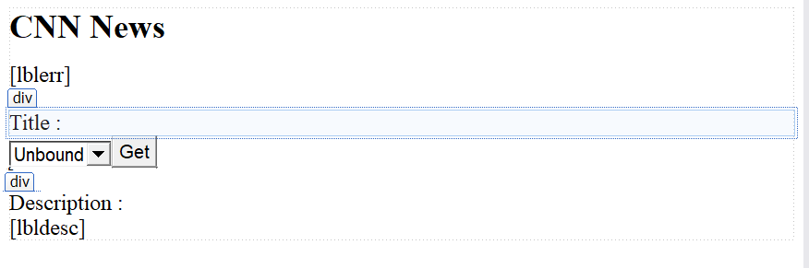

|  |  |  |
| --- | --- | --- |
| Web Form Control | Properties | Remark |
| Label | ID = lblerr | To display message when there is no news |
| DropDown List | ID="ddlTitle" | Contains list of articles |
| Label | ID= "lbldesc" | Contains description of article |
| Button | ID="BtnGet" Text=’Get” |  |

1. Switch to showRSS.aspx.cs page. Make sure to declare **using System.Xml** at the top of the page.
2. In the class, instantiate the xml document to hold the feed

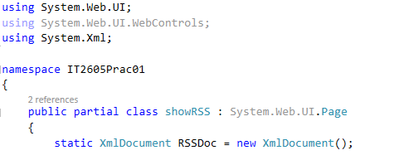

1. In the Page\_Load method,
   * Load the RSS feed from Channel NewsAsia into an XML document.

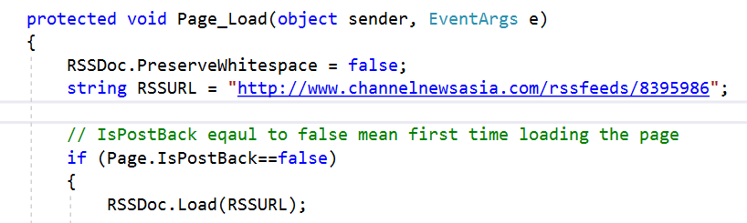

* + Retrieve the list of item element.
  + From the list, obtain the child element ***<title>*** and add each title to the item property in dropdownlist ***ddlTitle***

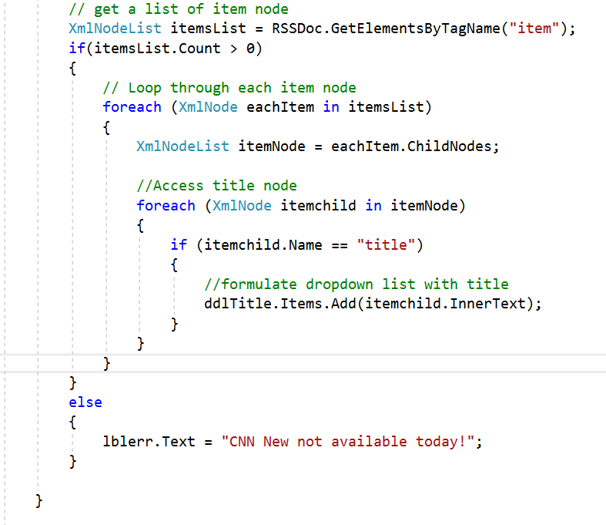

1. When the Get button is clicked, a list of articles’ title are propogated to the dropdown list.
2. Continue to write the code yourself to obtain the description of the article and displayed it to the label.
   * Compare title of each item element
   * If it is the same as item selected in ***ddlTitle***
   * Display the child element <description> in the label ***lbldesc***
   * Hint: You can use ChildNode[1] property to obtain title for each item

Use ChildNode[3] to obtain description for the correspondence item

1. Run the code, the result should be

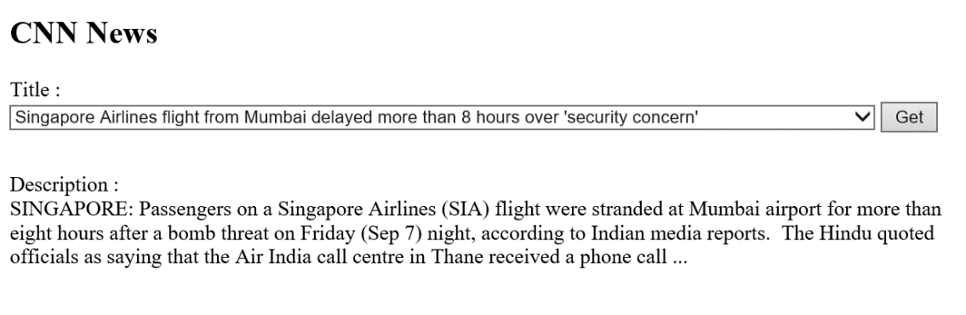

**check_tick_black2.jpg Checkpoint**

By the end of this practical, you should be able to:

Understand well-form and XML

Using DOM to access XML